Московский государственный технический университет
им. Н.Э.Баумана

Кафедра
«Системы обработки информации и управления»
(ИУ-5)

Отчёт по лабораторной работе №4
по курсу «Разработка интернет приложений»

Выполнил:
студент гр. ИУ5-53
Казаков Л.С.

Москва – 2017 г.

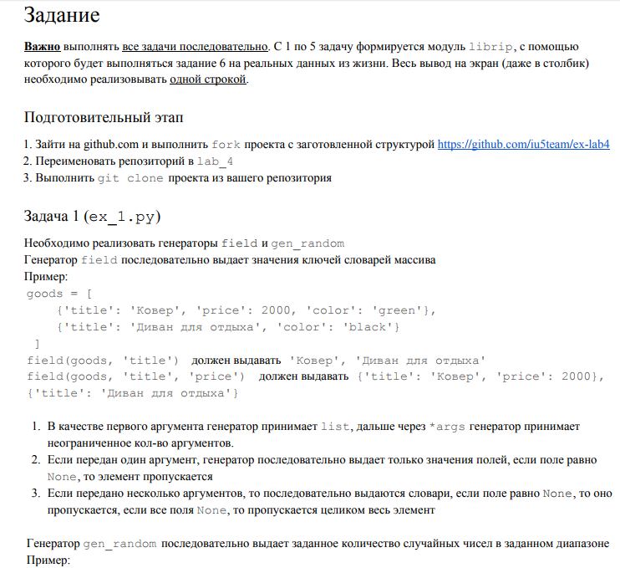

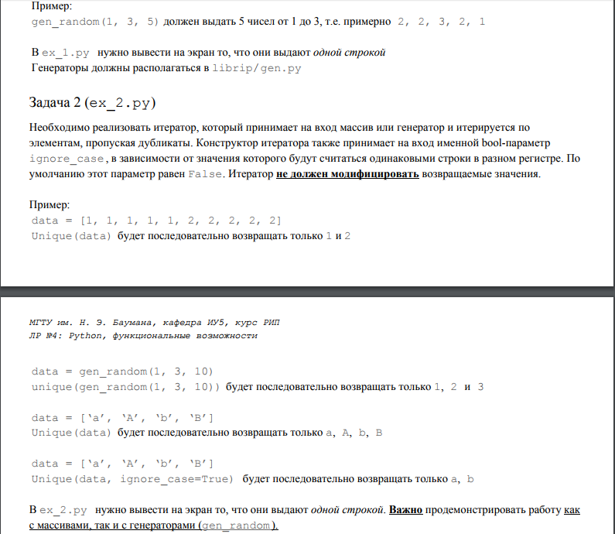
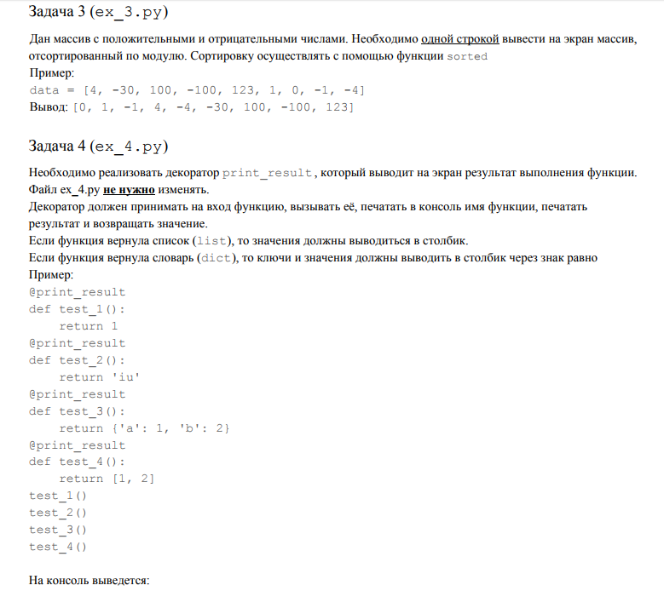
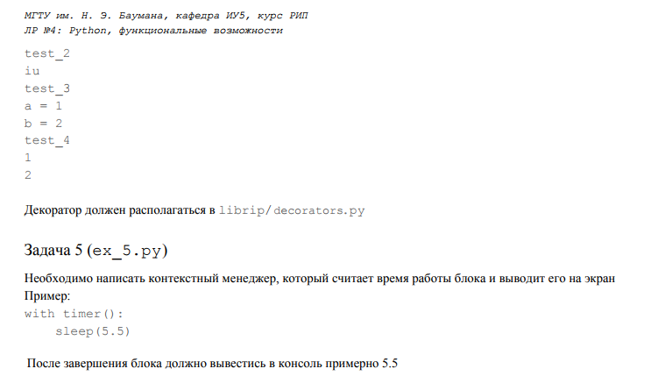

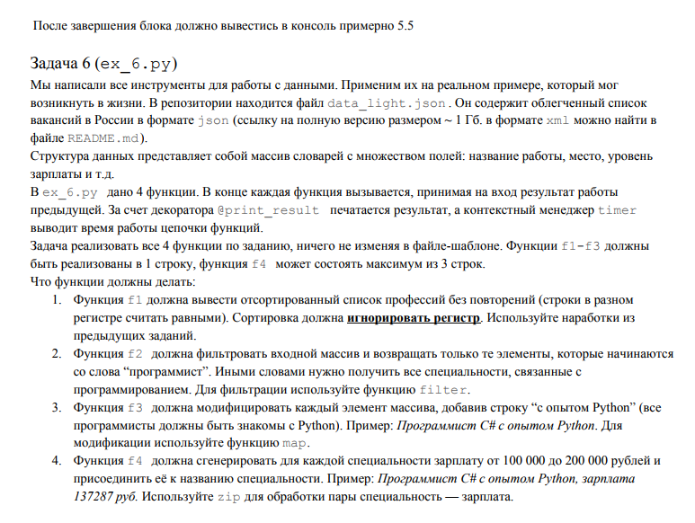

Код задания

Librip:
Ctxmngrs.py:

# -*- :coding utf-8 -*-
import time
class Timer:
def __init__(self):
pass
def __enter__(self):
self.start_time = time.time()
def __exit__(self, exc_type, exc_val, exc_tb):
print(time.time() - self.start_time)

Decorators.py:

# -*- :coding utf-8 -*-
def print_result(func):
def wrapped(*args, **kwargs):
result = func(*args, **kwargs)
print(func.__name__)
if type(result) == dict:
for key, value in result.items():
print('%s = %s' % (key, value))
elif type(result) == list:
for i in result:
print(i)
else:
print(result)
return result
return wrapped

Gens.py:

# -*- coding: utf-8 -*-
import random
def field(items, *args):
assert len(args) > 0
if len(args) == 1:
for item in items:
if item[args[0]]:
yield item[args[0]]
else:
for item in items:
output = {}
for i in item.keys():
if i in args:
output[i] = item[i]
else:
pass
yield output
def gen_random(begin, end, num_count):
for i in range(num_count):
yield random.randint(begin, end)

Iterators.py:

# -*- coding: utf-8 -*-
class Unique(object):
def __init__(self, items, **kwargs):
self.ignore_case = kwargs.get('ignore_case', False)
self.index = 0
self.item_set = set()
self.items = iter(items)
def __next__(self):
for i in self.items:
if i is not None:
original = i
if self.ignore_case and type(i) is not int:
i = str(i).lower()
if i not in self.item_set:
self.item_set.add(i)
return original
raise StopIteration()
def __iter__(self):
return self

data_light_cp1251.json – файл с кодом json

Ex1.py:
#!/usr/bin/env python3
# -*- coding: utf-8 -*-
from __future__ import print_function
from librip.gens import field, gen_random
goods = [
{'title': 'Carpet', 'price': 2000, 'color': 'green'},
{'title': 'Sofa', 'price': 5300, 'color': 'black'},
{'title': 'Shelf', 'price': 7000, 'color': 'white'},
{'title': 'Hanger', 'price': 800, 'color': 'white'}
]
# Реализация задания 1
print(', '.join(field(goods, 'title')))
for i in field(goods, 'title', 'price'):
print(i, end=', ')
print()

Carpet, Sofa, Shelf, Hanger
{'title': 'Carpet', 'price': 2000}, {'title': 'Sofa', 'price': 5300}, {'title': 'Shelf', 'price': 7000}, {'title': 'Hanger', 'price': 800},
5
3
4
5

Process finished with exit code 0

Ex2:

# -*- coding: utf-8 -*-
#!/usr/bin/env python3
from librip.gens import gen_random
from librip.iterators import Unique
data1 = [1, 1, 1, 1, 1, 2, 2, 2, 2, 2]
data2 = gen_random(1, 3, 10)
data3 = ['a', 'A', 'b', 'B']
# Реализация задания 2
a = Unique(data1)
b = Unique(data2)
c = Unique(data3)
d = Unique(data3, ignore_case=True)
drow = [a, b, c, d]
for i in drow:
print(', '.join(str(x) for x in i))
1, 2
3, 1, 2
a, A, b, B
a, b

Process finished with exit code 0

Ex3.py
#!/usr/bin/env python3
# -*- coding: utf-8 -*-
data = [4, -30, 100, -100, 123, 1, 0, -1, -4]
# Реализация задания 3
print(sorted(data, key=lambda item: abs(item)))
1, 2
3, 1, 2
a, A, b, B
a, b

Process finished with exit code 0
Ex4.py:
# -*- :coding utf-8 -*-
from librip.decorators import print_result
@print_result
def test_1():
return 1
@print_result
def test_2():
return 'iu'
@print_result
def test_3():
return {'a': 1, 'b': 2}
@print_result
def test_4():
return [1, 2]
test_1()
test_2()
test_3()
test_4()
test_1
1
test_2
iu
test_3
a = 1
b = 2
test_4
1
2

Process finished with exit code 0

Ex5.py:
# -*- :coding utf-8 -*-
from time import sleep
from librip.ctxmngrs import Timer
with Timer():
sleep(5.5)

5.511173725128174

Process finished with exit code 0

Ex6.py:
# -*- coding: utf-8 -*-
#!/usr/bin/env python3
import json
from librip.ctxmngrs import Timer
from librip.decorators import print_result
from librip.gens import field, gen_random
from librip.iterators import Unique as unique
path = 'data_light_cp1251.json'
with open(path) as f:
data = json.load(f)
@print_result
def f1(arg):
return sorted(unique(field(arg, 'job-name'), ignore_case=True), key=lambda item: item.lower())
@print_result
def f2(arg):
return list(filter(lambda x: 'программист' in x, arg))
@print_result
def f3(arg):
return list(map(lambda x: x + ' с опытом Python', arg))
@print_result
def f4(arg):
return(['%s, зарплата %s руб.' % (spec, sal) for spec, sal
in zip(arg, gen_random(100000, 200000, len(arg)))])
with Timer():
f4(f3(f2(f1(data))))

(очень объемный вывод)

